Village of East Syracuse
204 North Center Street, East Syracuse, NY 13057
Tel: 315-437-3541 Fax: 315-463-2150
Mayor  Lorene Dadey  Deputy Mayor  Mary Albanese  Trustees  Carol Para  Shawn Plourde  Bernard Ment  Justice  Robert Jokl  Village Clerk  Jennifer Scafidi  Parks & Recreation  Thomas Richardson  DPW Superintendent  Randy Hughson  Code Enforcement  Chris Shields  Fire Chief  Leonard DiBello |  | Village Board Meeting 2024  February 5, 2024  6:30pm  Minutes  Present: Mayor Dadey, Deputy Mayor Albanese, Trustee Plourde, Trustee Ment (in at 6:49pm)  Excused: Trustee Para  Also Present: Clerk Scafidi, Chris Shields (CODES), Chief Dibello (FD), Randy Hughson (DPW), Tom Richardson (PARKS), Nate Baker (FD), Chris Smith (DPW), Village of East Syracuse Lawyer Robert Germain  Start Time: 6:40pm  Pledge of Allegiance  - Motion to approve: Board Meeting minutes from January 3, 2024, Special Meeting minutes from January 12, 2024, Organizational Meeting minutes from January 3, 2024.  Motion By: Deputy Mayor Albanese  2nd By: Trustee Plourde  Polling the Board: Yes Motion Carried  - Motion to approve vouchers 67689 thru 67851 for the amount of $319,293.09.  Motion By: Deputy Mayor Albanese  2nd By: Trustee Plourde  Polling the Board: Yes Motion Carried  - Motion to move: $210.71 from account A1325.0409.0000.0000 (Treasurer training and seminars) to account A1410.0430.0000.0000 (Village Clerk other expense) to pay the SAM registration annual fee.  (Mayor Dadey explained that we pay a SAM registration annually for the Village to obtain grant money)  Motion By: Deputy Mayor Albanese  2nd By: Trustee Plourde  Polling the Board: Yes Motion Carried  - Motion to approve: to give Mayor Dadey authorization to sign the C & S Engineering Contract for 2024 for Hanlon Pool.  Motion By: Deputy Mayor Albanese  2nd By: Trustee Plourde  Polling the Board: Yes Motion Carried  - Motion to approve: the use of Ellis Park by Exceptional Family Resources as Home Base for project Explorer program – a summer for children with developmental disabilities from  June 24th -August 23rd.  (Tom Richardson explained that they have used our pavilion for the last several years and they pay to use Hanlon Pool)  Motion By: Deputy Mayor Albanese  2nd By: Trustee Plourde  Polling the Board: Yes Motion Carried  - Motion to hire Cam Smith and Tony J. Albanese II as part time caretakers at a rate of $17.00/hour with a starting date of Saturday, February 10, 2024 (Deputy Mary Albanese stated Tony J Albanese II is of no relation to her)  Motion By: Deputy Mayor Albanese  2nd By: Trustee Plourde  Polling the Board: Yes Motion Carried  - Motion to Re-allocate funds in the amount of $217.78 from A.3410.0430.0001.0002 (Fire Dept Station 2 Toshiba Copier Lease) into A.3410.0430.0000.0002. (Fire Dept Other Expense) to correct payment for copiers taken from wrong account.  Motion By: Deputy Mayor Albanese  2nd By: Trustee Plourde  Polling the Board: Yes Motion Carried  - Motion to Re-allocate funds in the amount of $1,000.00 from account A.1325.0409 (Treasurer Training and Seminars) into A.1410.0407 (Village Clerk Copier Lease) to cover Village copier costs for the remainder of the budget year.  (Mayor Dadey explained that the original budget didn’t budget enough for copies)  Motion By: Deputy Mayor Albanese  2nd By: Trustee Plourde  Polling the Board: Yes Motion Carried  - Motion for the Board of Trustees to approve the Fire Departments request for the purchase of the Fire Department Rope and Rope Equipment in the amount of $6039.99 (lowest of 3 quotes)  (Chief Dibello states this is to update the current rope they use now.  This rope will give them more capability for all future calls)  Motion By: Deputy Mayor Albanese  2nd By: Trustee Plourde  Polling the Board: Yes Motion Carried  - Motion to authorize Tom Richardson to bid on a school bus being sold by the Town of Dewitt at auction through Auction International up to $4200.00 (Trustee Ment arrived now at 6:49pm)  Tom Richardson explained that we borrowed this bus in the past from the Town of Dewitt. This bus can be used for a lot of programs for the children and seniors. Charter buses would cost a lot more money. We have the bus drivers.  Deputy Mayor Albanese: asked if we need to worry about fuel cost.  Mayor Dadey: yes, we would need to budget a repair and fuel line)  Mayor Dadey: asked Trustee Ment if he had any questions before polling the board.  Trustee Ment: Yes. How old is the bus?  Tom: 2010  Trustee Ment: What is the mileage?  Tom: 110,000 miles  Trustee Ment: What is the life expectancy for the bus with this many miles?  Tom: Not sure  Mayor Dadey: This bus will be used for short trips.  Trustee Ment: What I’m concerned about is when it becomes that old, we will start having problems with it breaking down and will have to be maintained.  Tom: It must be maintained every 45 days and inspected every six months. It will be kept up and it has already been kept up.  Motion By: Deputy Mayor Albanese  2nd By: Trustee Plourde  Polling the Board: Yes Motion Carried  - Motion to Re-Allocate funds in the amount of $1000.00 from Account A.1325.0401 (TREASURER/OFFICE SUPPLIES) to A.1410.0407 (VILLAGE COPIER) to cover costs for the remainder of the year.  Motion By: Trustee Ment  2nd By: Trustee Plourde  Polling the board: Yes Motion Carried  - Motion to approve James Dispenza, owner of 219 South Center Street East Syracuse, to move forward with his project for Game Point Sports Facility. The project consists of turning the property into Pickle Ball Courts. On January 8, 2024, the Village of East Syracuse Planning Board recommended approving this project subject to the Engineer, Steven Snell’s approval.  Mayor Dadey asked if anyone was there from this project, and no one was present this night. Chris Shields explained that this project is located where Speedy Medical is on South Center Street. Right next to Speedy Medical is an empty warehouse that would be turned into a gymnasium used for basketball or a couple of pickleball courts. There will be locker rooms and restrooms. There will be a small cafeteria with drinks and snacks only. Then they want to build a 2nd gym on the other side which will be a second basketball court or a couple more pickle ball courts. The planning board met on 1/8/24 with the owner, architects, and developers. They had questions from when they met in December. The project did not meet the greenspace requirement for a commercial lot. They did not want to go in front of the zoning board. They went back to the drawing board with their architect. They came back on 1/8/24 showing the planning board that they met the requirement. At the end of the meeting with the planning board on 1/8/24, the Planning board voted a motion to recommend to the Village Board that they are in favor of the project subject to the engineer’s approval.)  Mayor Dadey: Has Steve sent back his comments yet?  Chris: No.  Mayor Dadey: Has the project been turned over to Steve?  Chris: Steve has been involved. They need approval so they can move forward and they don’t want to spend thousands of dollars for blueprints for Steve until they know they got your blessing to move forward. They are just looking for the Village Board of Trustees to vote on it and approve it pending the engineer’s approval.  Deputy Mayor Albanese: is there enough parking?  Chris: Yes they do. There is a parking area connected to the building. They also have a parking lot over to the right and then another parking lot across the street which can hold another 25-30 cars.  Mayor Dadey: any comments or questions?  Trustee Ment: What is pickle ball?  Mayor Dadey: It is like tennis and paddle ball.  Motion By: Deputy Mayor Albanese  2nd By: Trustee Plourde  Polling the Board: Yes Motion Carried  - Motion to re-allocate funds in the amount of $600.00 from A.1325.0401 (TREASURER OFFICE SUPPLIES) to A.7140.0401.0000.0002 (PARKS COPIER) to cover costs for the remainder of the year.  Motion By: Deputy Mayor Albanese  2nd By: Trustee Ment  Polling the Board: Yes Motion Carried  - Motion to approve $95,000.00 payment to the East Syracuse Fire Department Inc. contingent upon receipt of Town of Dewitt’s payment.  Motion By: Deputy Mayor Albanese  2nd By Trustee Ment  Polling the Board: Yes Motion Carried  - Motion to approve application to State of New York pursuant to the Home Rule Laws to expand residency for the Judge position from Village to include the Township of Dewitt.  Mayor Dadey: I’m asking for permission to fill out the application. It then will go down to Albany and they make the decision.  Robert Germain: stated if we change the residency, we are over the threshold for how many people live in the village. The only way for this to be done is by the state legislature. We need a motion to apply to State Legislature for special legislation.  Mayor Dadey: It would expand it. She stated because of the size of the village, this needs to be done. Otherwise, we could just pass a Local Law)  Trustee Ment: Is there anyone that lives in the Village besides Judge Zavaglia that is a lawyer and a judge?  Mayor Dadey: No  Motion By: Deputy Mayor Albanese  2nd By: Trustee Ment  Polling the Board: Yes Motion Carried  BOARD MEMBER COMMENTS:  Mayor Dadey: Ryan, I see you are sitting here in the audience, and I know you have a project pending.  Ryan Benz: Mayor Dadey, it was my understanding that we were supposed to be on the agenda.  Mayor Dadey: Yes, they notified me you wanted to be on the agenda. However, you and I talked, and you were supposed to take care of the parking issues. We are continuing to get complaints about parking.  Ryan: Since you and I last spoke, The Legacy Foundation went thru the ESE process to request a special use permit. We filled the application out and it was approved. I spoke with Deacon Joe Lupia. I have written confirmation from him that we could use St Matthews parking lot. There are 12 spots on West Yates St. There is additional parking in the parking lot as long as the church has nothing going on subject to their approval. They would look for the same insurance requirement.  Mayor Dadey: All I’m asking of you, we need to see those in order to get our blessing. We have had a lot of complaints of cars being parked all over. We are trying to work with you and protect our community. We want this to be a huge success for you.  Ryan: I have those written. I just got Deacon Joe’s today. I have a photograph of the approval from ESE. I can email that to you. As part of our design, we got rid of the srea where the bus drop off is and will be replacing with grass. We have been coning it off to curb this. We put these in place as a band aid until the grass is replaced. We need 56 parking spaces. We have 38. The legacy foundation will need to educate the parents until we have a solid solution. We have added spaces at the church. I think we’ve done everything possible to move this project forward.  Deputy Mayor Albanese: We received a letter from Dr Desiato and it said it is NOT ok and have to go in front of the board each time.  Ryan: We received a letter. We understand there is no tangible acceptance of ESE. Makes sense for Legacy Foundation to add ESE to insurance binder.  Trustee Plourde: Will there be signs saying additional parking at St Matthews?  Mayor Dadey: Randy and Ryan had a conversation about putting up signs. Your comfortable right Randy?  Randy- Yes, correct.  Mayor Dadey: Randy is in charge of Public Safety.  Ryan: I have been a good of neighbor as good as I can. We will listen and do whatever it takes.  Mayor Dadey: Chris, what do you think?  Chris: on 1/8/24, The Planning Board motioned to recommend to the Village Board that they are in favor of the project with the understanding that both sides of the building will be green. Since then, Ryan dropped off the architectural showing both sides are green.  Mayor Dadey: Robert, do you have anything to add?  Robert: No  Mayor Dadey: as long as there is a partnership with ESE and St Matthews  Ryan: I will be happy to forward the emails to you.  Mayor Dadey: Bernie, do you have any comments?  Trustee Ment: You said there is parking 2 blocks away. I know people are not going to park 2 blocks away when they can find a parking space on the street.  Mayor Dadey: we talked to Randy to get labeled what side to park on.  Motion to approve Ryan Benz’s plans for condominiums to retrofit St. Matthews parochial school into condominiums.  Motion By: Trustee Ment  2nd By: Trustee Plourde  Polling the Board: Yes Motion Carried  MORE BOARD MEMBER COMMENTS  Mayor Dadey: I would like to mention that Clerk Scafidi sent out the budget email with the budget worksheets. Please start working on your budget with your liaisons. Please get the preliminary budget in in February so we can take a look at them.  Deputy Mayor Albanese: For the Public Hearing for the Local Law 1-2024, both Mayor Dadey and I will be attending the Fire Department membership meeting on 2/6/2024 to go over it with them.  Mayor Dadey: Working with the Fire Department has never been like this in all the years that I have been in Government. Do we have to do it? No, but do we want to do it, Yes!  Mayor Dadey mentioned that our very own Deputy Mayor Albanese received the Golden Spartan Award today by the East Syracuse Board of Education. The award honors outstanding achievements & contributions within our District. Congratulations Mary!  Mayor Dadey wanted to Thank Dave Delpriore for all that he does helping everyone out around the Village office. He always does what is asked of him quickly and efficiently.  Deputy Mayor Albanese: Wished Chris Shields, Code enforcement officer, Happy Birthday!  Trustee Plourde: No comments  Clerk Scafidi: No comments.  Trustee Ment: apologized for being late to this meeting.  Deputy Mayor Albanese mentioned she will not be able to attend the March Board meeting and will need to be Excused. Mayor Dadey excused her.  RESIDENT COMMENTS:  Jordan Bellassai: you know the Stem Children who came in, was there any more consideration implementing that?  Deputy Mayor Albanese: Those were our elementary kids. There was a lot more involved and a lot money.  Jordan: They did a great job. ok, so there is a financial reason.  Herb Schrayshuen- regarding the residence of the judge, do we have a justice now that can serve?  Mayor Dadey: Yes, he is an appointed position. He is our acting justice. Our Justice is down in Family Court now. There will be an election in November.  Herb Schrayshuen- OK so to be eligible for election, they would have to meet the resident requirements.  Mayor Dadey: That’s correct.  Herb Schrayshuen: for the public participation in the budget formation process, will you involve volunteers from the public for various aspects of the budget.  Mayor Dadey: No, we have a round table discussion of the budgets. If anyone wants to come and give their input, they certainly are welcomed to but usually it is just with the department head.  Herb Schrayshuen: where is the schedule posted for those dates?  Deputy Mayor Albanese: They are not scheduled as of yet  Mayor Dadey: It will be in March.  Herb Schrayshuen: will there be a public posting of the schedule?  Mayor Dadey: Yes, if you want to come and look at the budget once we have a preliminary budget, you are more than welcome to pick up a copy to look at. It will be posted.  DEPARTMENT COMMENTS:  Village Clerk: No comments  DPW: Randy Hughson  TREES Good size tree fell on West Ave @ Yates St. The crew came in cut it all up and hauled it away. We have been through the village every day for the month picking up Christmas trees. We have not seen any for the past 2 days, may be done.  SIGNS-Replace 2 street address. signs  DPW-Made up a buildings & grounds safety check list, found a couple problem,  fixed them and had signs made up NO SMOKING IN BUILDING installed them on  the 3 entrance doors. Luke did his defensive driving course, Grace, the driving instructor came in and certified Jeff so he can sign up for his road test. Took the decorations down on main street and put them away.  WEATHER- We had heavy rains and high winds for the month. There was flooding and alot of tree limbs down. The crew kept the catch basins open and the tree limbs were picked up.  SIDEWALKS- We have 2 applications for sidewalks already. It will be a busy sidewalk summer, I think.  PARKS-Helped take down the decorations at the municipal building and put them away.  SNOW-Salt trips-18. Plow trips-5, Parking lots-3, Sidewalk plow 3 trip (full route). So far, I have ordered 170 tons of salt. That budget line is still looking good.  FIRE DEPARTMENT-Chief DiBello  Chief Dibello wanted to say that he has never seen so much cooperation between the Village Board of Trustees and the Fire Department and he wants to thank them for this. Request for approval to purchase new rope and rope equipment. This rope and equipment will upgrade what we currently have on the trucks. This purchase will also expand our capabilities when it comes to certain types of calls. Given the amount of the purchase, form B and quotes have been provided.  I would like to thank Mayor Dadey and trustee Plourde for attending the coalition breakfast on 1/27 along with myself and asst chief Paul Haynes. One of the topics covered was about transitioning to a combination fire dept, a process we are in the beginning phase of. There was a very lengthy discussion. The information provided coincided exactly with the plan that our staffing committee has come up with. There are a lot of moving pieces as we move forward with hiring the paid chief and eventually paid firemen to supplement our volunteers. It is great to know that we have a great group of fire chiefs and municipal officials out there to assist us in getting this in new model in place. I would also like to thank Deputy Mayor Albanese and former trustee Raesky, they have been involved with our staffing committee from the beginning. Deputy Mayor Albanese continues to be involved and now will be joined by Mayor Dadey. This committee, made up of members of our dept and members of the Board have worked diligently over the last several months to come up with a solution to our issue, and only now we are starting to see the results of our hard work. I have had many people from other depts speak very positively about what we are doing and that we should be commended for acknowledging the problem and trying to fix it.  Nate Baker: mentioned there have been a few more Volunteer Firemen coming around now.  PARKS AND RECREATION- Tom Richardson  Family Roller-skating was held on Saturday, January 20^{th.} A total of 27 people participated.  The 3rd annual Pre-K Prom was held on Saturday, January 27th from 4:30pm – 6:00pm at the Village office. Approximately, 35 children attended with their parents, grandparents, and guardians. Everyone had a great time.  The inter-generational program between East Syracuse Elementary students and the Keener Seniors continued January 31st. Students played bingo with the seniors and celebrated January birthdays.  Senior Valentine’s Day Party –The ESM Highschool Chorus will be performing at Heman St. apartments on February 14th during the senior luncheon. Bingo at 11:00am, lunch at 12:00 noon, entertainment at 12:30pm.  16 seniors played pitch in the monthly card party on Thursday, January 18th. The next party is February 15th.  The Movie Taken Chance was shown to seniors on Thursday, January 25th at the Village office 2nd floor. The next movie is on February 8th.  Ice Skating Rink – It was open for 3 days from January 19th – 21st. Dave did a great job getting everything ready. The next week the weather didn’t cooperate. (ice melted).  Kid’s Disney on Ice – (Weather Permitting) will be held on Thursday, February 8th at Ellis Field Park from 4:00pm - 7:00 pm.  Teen Skating Night will be held on Friday, February 16th (weather permitting) from  4:00pm – 7:00pm at Ellis Field Park.  EAVES will be holding a Baby-Sitting course on Tuesday, February 21th from  9:00am – 11:00:00am at the EAVES building. The cost is $60.00. Register at the Village office.  Registration is underway for February break youth activities (February 20 – 23). Forms are available at the Village office and online. Activities include Sky Zone, Chuck e cheese, bowling, bingo & Movie, 3 on 3 basketball Tourney, Intramurals.  Family Trivia Night will be on Wednesday, February 28th, from 6:00pm – 7:30pm on the 2nd floor of the Municipal Building.  13 orders were taken for Food $ense in January. Orders for February Food $ense are due before or on February 9th. Call Tom Richardson @ 315- 952-0038 for more information.  Spring Festival Fest is taking place on Saturday, April 13th from 11:00am – 2:00pm at Ellis Field Park. See the website for more info.  Earth Day Cleanup is scheduled for April 20th.  Tom Richardson wanted to thank the Village Board of Trustees for the possible opportunity of purchasing the bus at the auction.  Park Maintenance-Tom Richardson  Take down and put away holiday decorations trees/hill  Install ice rink liner and clips, add water, secure with snow fence, setup wis bldg, and skate walkway (benches, mats, railing, concessions) resurfacing as needed (hot water/Zamboni).  Plow/shovel/salt as needed park/Village office – assisted DPW on Saturday during storm.  Remove old toilet and install new one in pool building – family restaurant.  Install new toilet seat and address leaky toilet (3rd floor Village office)  Check park/VO perimeter as needed/weather allows litter/branches, park small tree (walking path) fell, cut up toss into woods.  Lubricate pad locks park (freeze/sticking)  Other tasks as needed/available. (senior luncheon, senior card party, Food sense)  Turn off leaking spigot (front FD) shutoff in drop ceiling  CODE ENFORCEMENT COMMENTS-Chris Shields  Buildings Report- January 2024  - Overhead door had to come out twice last month. Once to make adjustments and another time to replace the electronic safety strip that went bad along the bottom of the rescue 1 door.  - One of the 75-gallonhot water heaters blew in the basement sometime between January 26th and 27th. There was an inch of water throughout half the basement. I sucked up the water throughout the weekend and Syracuse Plumbing came on Tuesday and replaced the tank. I also had them add a valve between the 2 tanks so if in the future, if one tank goes down, we can still use the other tank so we have some hot water.  - Had a couple other minor plumbing issues that Dave took care of for me so we didn’t have to hire anyone for that.  - Bill Pindle, the electrician, is going to be contacted this week. The light over the police substation door is flickering. The last time this happened to one of the exterior lights of that type, the entire light had to be replaced.  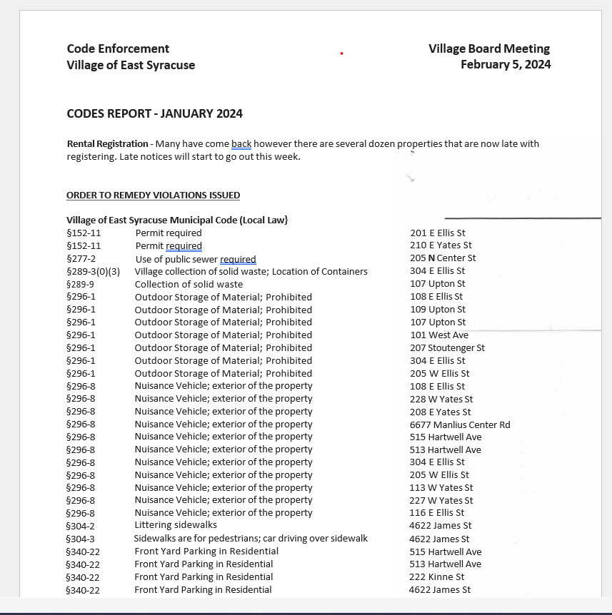
 |  | 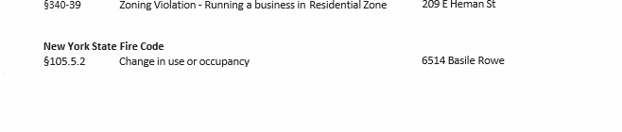

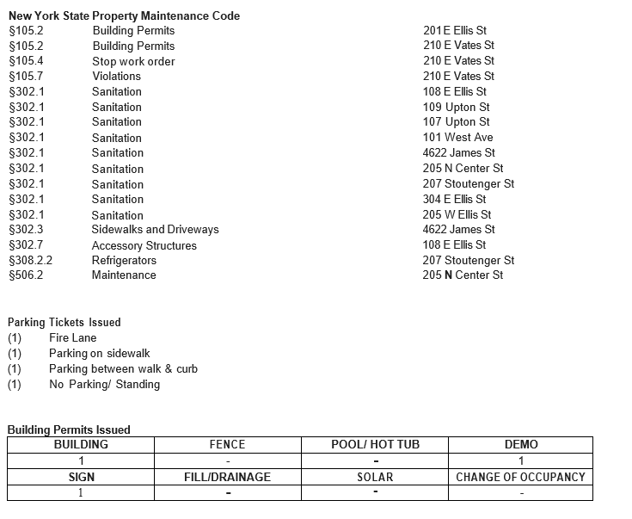

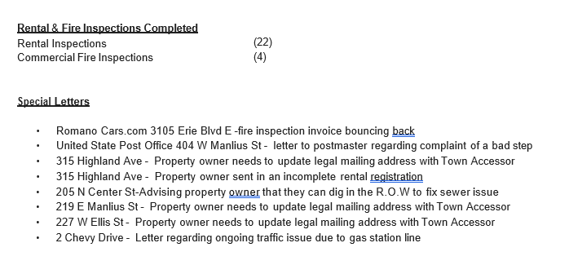
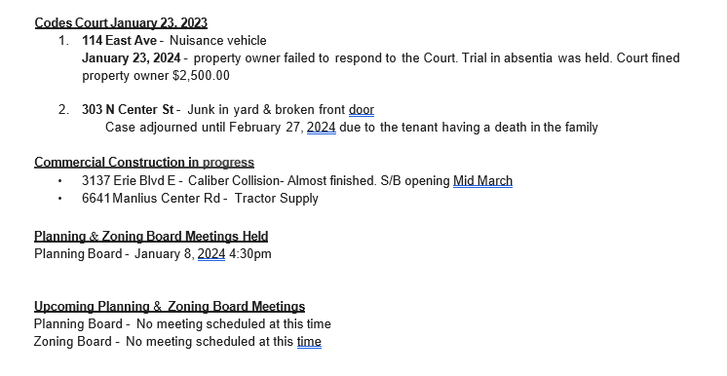Motion to Adjourn at 7:46pm
Motion By: Trustee Ment
2nd By: Trustee Plourde
Polling the Board: Yes Motion Carried

